Mr11 downlights recessed satin
In our article we describe one of the products available in the Future House Store - mr11 downlights recessed satin.

Downlights and others lighting details

In interior architecture, minimalist solutions are still very popular, which assume the use of chromatic colors such as metallic, gold or silver. Also in lighting these colors are definitely the most popular among customers. In combination with LED lighting, they create modern solutions that are widely used all over the world. That is why in the Future House Store online store there are such offers as mr11 downlights recessed satin.

Mr11 downlights recessed satin - minimalism and modern

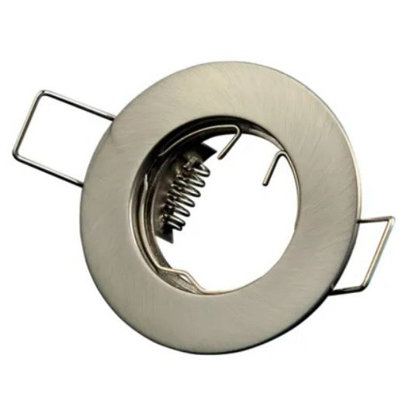
The ceiling luminaire in golden color, which is compatible with LED lighting is a combination of the latest lighting technology with minimalism. Thanks to such a solution, this ceiling luminaire can be used in virtually any interior. Mr11 downlights recessed satin is suitable for mounting MR11 halogen bulbs with a diameter of 35 millimeters. The online catalog of the Future House Store online store contains ceiling luminaires that were made of excellent quality materials, e.g. from broken aluminum or glass, sandblasted and brushed luminaires. If you are interested in modern solutions in lighting, it is definitely worth getting acquainted with the assortment of the above-mentioned store which is available on the website

