**Mr11 light fittings white**

**One of the products available in the Future House Store online store, which specializes in selling lighting-related items. More on this topic in our article, welcome!**

**Main light source**

If you are at the stage of planning lighting in your apartment or house, or just the time has come for small changes and you would like to carry out renovation in your apartment, including lighting, our tip is that you pay special attention to a good combination of the main light source with additional lighting rooms. Ceiling light, i.e. ceiling-mounted lamps, is usually considered the main light source. Why? Because it is the most strategic place that gives a lot of artificial light. For this purpose, you can use the product [mr11 light fittings white](https://futurehousestore.co.uk/non-waterproof-downlights/led-line-mr11-cone-recessed-ceiling-downlight-white.html) or other downlights from the Future House Store online store.

**Mr11 light fittings white**

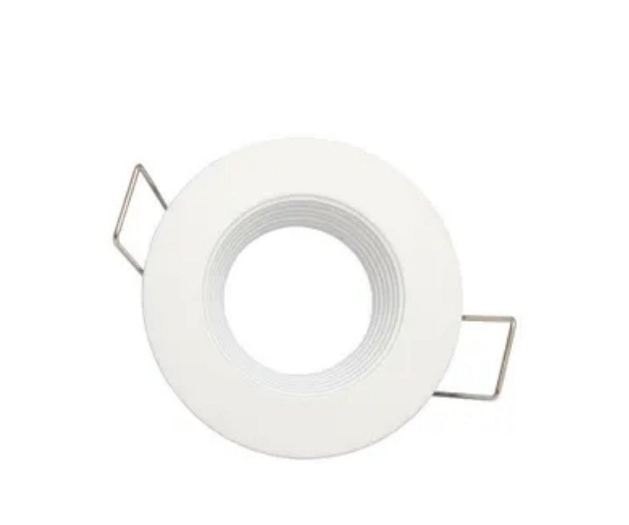

To make LED bulbs or halogens look good mounted on the ceiling, it is worth buying luminaires in which they will not only be installed safely, but will also look stylish. We encourage you to choose ceiling holders from the Future House Store online store. It is worth paying attention to downlights such as **mr11 light fittings white**. The frames are made in many colors and from different materials. Sandblasted and brushed as well as cast or molded aluminum, we also offer glass holders and smoother versions of extruded aluminum.